BIOS 497/897
HW7: Preprocessing and assessment

(1) Application of RMA on SpikeInSubset.
A. Comparing boxplots before and after RMA background correction. Please use the same scales for the Y-axis in boxplots; you may use such as ylim=c(0,15) in the boxplot function.
B. Compareing hist() plots before and after RMA normalization (quantiles).
C. Please discuss your results little bit.

Answer:
Codes:
>#For question one
>library("affy")
>library("SpikeInSubset")

>data(spikein133)
>spikein133

>#For question 1A
>boxplot(spikein133, ylim=c(0,15), >col=c("red","red","red","green","green","green"))
>savePlot("before_bg_correction", type="jpg")
>spike_after_bg_correction = bg.correct(spikein133, method="rma")
>boxplot(spike_after_bg_correction, ylim=c(0,15), >col=c("red","red","red","green","green","green"))
>savePlot("after_bg_correction", type="jpg")

>#For question 1B
>hist(spike_after_bg_correction)
>savePlot("before_normalization", type="jpg")
>spike_after_normalization = normalize(spike_after_bg_correction, method="quantiles")
>hist(spike_after_normalization)
>savePlot("after_normalization", type="jpg")

(A) plots

Before RMA background correction After RMA background correction
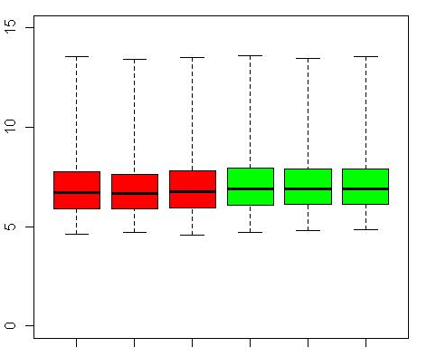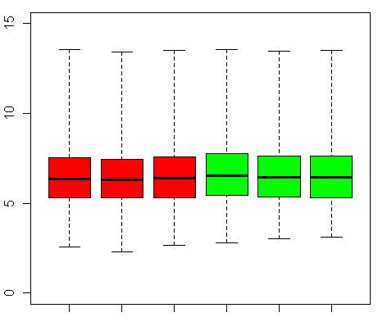

Discussion:
From the two figures, we may find the distribution of values become wider after RMA background correction, and the minimum value for each chip goes closer to 0. This indicates that the RMA background correction works.

(B) plots

Before normalization After normalization
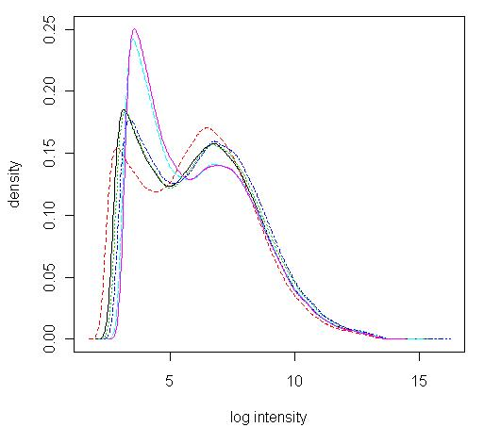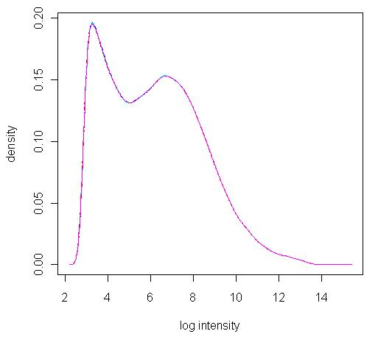
Discussion:
Here I used the data after the background correction. By comparing the figures above, we can find that the curves overlap to each other after normalization. It means the density distributions for different chips are similar after normalization. We need to know the number of differentially expressed genes is a small number compared with the total number genes in the whole genome.

(2) Comparison between MAS5() and RMA()
- Editing a source code file
- Preprocessing SpikeInSubset with MAS5()
- Using function of “exprs()” get the processed expression value.
- Displaying the histogram of logarithm values of the first sample set. e.g.“hist(log(bf[,1]))”
- Saving this figure.
- Repeating all above steps with RMA() method
- Comparing two figures.

If you have interest, please read this paper for more information: Wu Z, Irzarry RA. Preprocessing of oligonucleotide array data. Nature Biotechnology 22, 656 - 658 (2004).

Answer:
Codes:
># Question two
>data(spikein133)

># MAS
>expression_MAS = mas5(spikein133)
>bf_MAS = exprs(expression_MAS)
>hist(log(bf_MAS[,1]), main = "Histogram of logarithm values of the first sample set", xlab = "log(first sample set)")
>savePlot("MAS", type="jpg")

># RMA
>expression_RMA = rma(spikein133)
>bf_RMA = exprs(expression_RMA)
>hist(log(bf_RMA[,1]), main = "Histogram of logarithm values of the first sample set",xlab = "log(first sample set)")

>savePlot("RMA", type="jpg")

MAS5 RMA

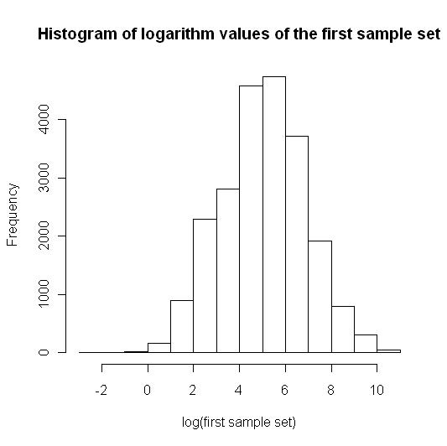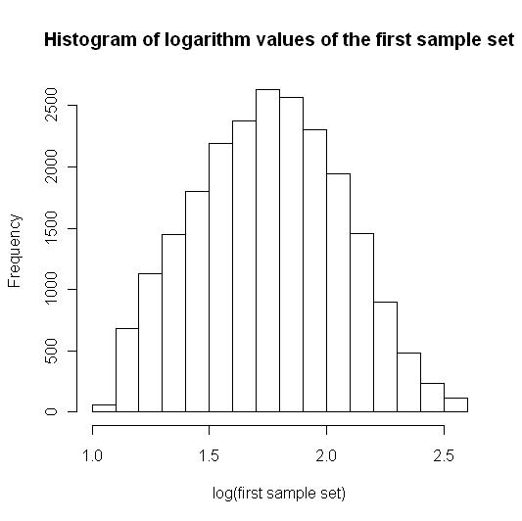

Discussion:

Comparing above two figures, we can find data after MAS5 have larger values than those after RMA. However, the data after MAS5 has a narrow distribution than the RMA one does; the value of peak in MAS5 figure is larger than that of the RMA one.

(3) MA-plot. Please make MA-plots for the first and forth samples of spikein133 before and after RMA process. Please discuss your results little bit.

Answer:

Codes:
># Question three
>data(spikein133)

>y = (exprs(spikein133)[, c(1, 4)])
>ma.plot(rowMeans(log2(y)), log2(y[,1]/y[,2]), cex=1)
>title("Before RMA process")
>savePlot("MA_before_RMA", type="jpg")

>expression_RMA = rma(spikein133)
>y = (exprs(expression_RMA)[, c(1, 4)])
>ma.plot(rowMeans(log2(y)), log2(y[,1]/y[,2]), cex=1)
>title("After RMA process")

>savePlot("MA_after_RMA", type="jpg")

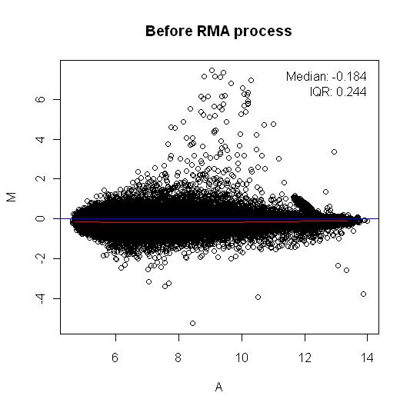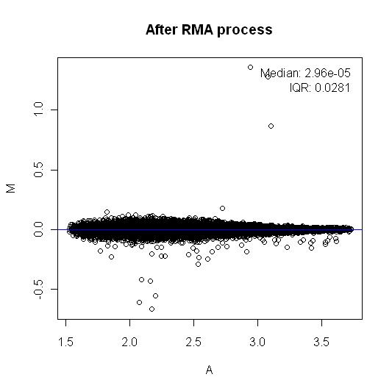

Discussion:

Comparing the MA plots before and after preprocessing, we can find that the differences of expression values between the first and fourth sample decrease, i.e., data points move closer to the line of y=0 after RMA preprocessing. This indicates the preprocessing procedure works; after all most genes do not change their expression levels for the treatment and the “M” values of those genes shall be around zero.

(4) Detect possible RNA degradation with AffyRNAdeg plots and summary. Please use AffyRNAdeg functions to plot the covariation with probe position for four samples of spikein133 and report the summary of AffyRNAdeg. Please briefly interpret the plot and summary result you obtain.

Answer:

Codes:
># Question three
>data(spikein133)

>RD<-AffyRNAdeg(spikein133[,1:4])

>plotAffyRNAdeg(RD)

>summaryAffyRNAdeg(RD)

12_13_02_U133A_Mer_Latin_Square_Expt6_R1
slope 1.62e+00
pvalue 1.87e-07

12_13_02_U133A_Mer_Latin_Square_Expt6_R2
slope 1.52e+00
pvalue 8.13e-07

12_13_02_U133A_Mer_Latin_Square_Expt6_R3
slope 1.63e+00
pvalue 2.62e-07

12_13_02_U133A_Mer_Latin_Square_Expt7_R1
slope 1.64e+00
pvalue 1.17e-07

Discussion:
The more the slope is close to zero, the better the RNA quality is. However, there is no a threshold for 'good' values of the slopes. There is another more important issue that we need to know from the plot is how the slopes compare within a given set of chips. If those curves are all relatively parallel, this indicates that the RNA degradation were relatively similar for all of the samples and they are comparable. Since we are only interested in comparisons within a given set of chips, if those data are comparable is much critical. For our case, the spikein data have parallel curves, thought their slopes are not so small, and hence, they are good for further comparisons.

