BIOS 426/826
Homework Assignment 6: Microarray data - SpikeInSubset
Due by Oct 22, 11:59PM

(2) load SpikeInSubset data
> library(“affy”) #include Affy package
> library("SpikeInSubset") #include SpikeInSubset package
> data(spikein133) #load spikein133 data set into R
> spikein133

What do you see here? What do they mean?
There are 6 samples and each has 2230 genes.

> x= exprs(spikein133) #extract gene expression data and save into “x”
> dim(x)

How many samples does this data set have? How many probes does this chip have?
6 samples and 506944 probes

> xpm=pm(spikein133)
> dim(xpm)

Can you get the intensity values of PM for the first probe set? How?
> pm(spikein133)[1,]

Can you display the first 3-samples in red and the second 3-samples in green? How?
> boxplot(spikein133,col = c(2,2,2,3,3,3))

(3) Plot the intensity of (PM-MM) for probe of “121_at” for all 6 samples. Please set suitable range for x-axis and y-axis. So, you need to know how many probes in this probe set. Please set x-label as “Probe-121_at”, and y-label as “PM-MM”.

> plot( c(1,16), c(-300,1100), type='n', xlab='Probe-121_at', ylab='PM-MM', cex.lab=1)
> for (i in 1:6) lines(pm(spikein133, "121_at")[,i]-mm(spikein133, "121_at")[,i], col=i)

(4) Apply RMA methods on SpikeInSubset.
A. Comparing boxplots before and after RMA background correction. Please use the same scales for the Y-axis in boxplots; you may use such as ylim=c(0,15) in the boxplot function.
B. Comparing hist() plots before and after RMA normalization (quantiles).
C. Please discuss your results little bit.

>#For question 4.A
>boxplot(spikein133, ylim=c(0,15), col = c(2,2,2,3,3,3))
>spike_after_bg_correction = bg.correct(spikein133, method="rma")
>boxplot(spike_after_bg_correction, ylim=c(0,15), col=c(2,2,2,3,3,3))

>#For question 4.B

>hist(spikein133,col=c(2,2,2,3,3,3))
>spike_after_normalization = normalize(spikin133, method="quantiles")
>hist(spike_after_normalization, col=c(2,2,2,3,3,3))

(A) plots

Before RMA background correction After RMA background correction
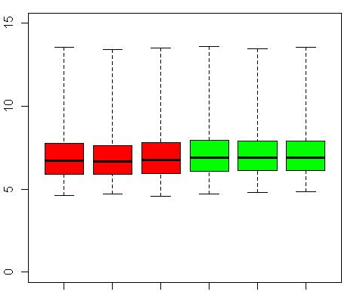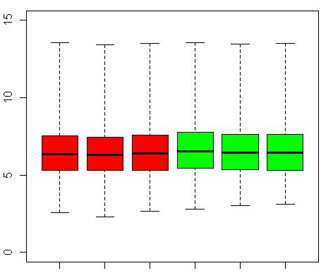

Discussion:
From the two figures, one can find the distribution of values become wider after RMA background correction, and the minimum value for each sample goes closer to 0. This indicates that the RMA background correction works.

(B) plots

Before normalization After normalization
Discussion:
Comparing the above two figures, one can find that the curves overlap to each other after normalization. It means the density distributions for different samples are similar. We need to know the number of differentially expressed genes is a small number compared with the total number genes in the whole genome.

